**Student: Amir Mohamed**

**ID: 21905318**

| **Module code and title:** | CO650  Advanced Programming | **Module leader:** | Guy Walker |
| --- | --- | --- | --- |
| **Assignment No. and type:** | CW 1 | **Assessment weighting:** | 100% |
| **Submission time and date:** | 23/08/2023 | **Target feedback time and date:** | +3Wks |

GitHub Link: -

<https://github.com/Amir94Mohamed/CO650A.D.-Referal/tree/main>

Contents

Task 1: - 3

GitHubLink: - 3

Project Background: - 3

Class Diagram: - 3

Output: - 3

Abstraction 4

Encapsulation 4

Inheritance 5

Polymorphic Behaviour 5

Overloading 5

Friendship 6

Static Members 6

Constructors 7

Pointers 7

Functional Pointers 7

Task 1 Conclusion: - 8

Extra Code Explanation : 8

Task 2: - 9

Classes Link: - 9

Code ScreenShots 10

Server.cpp 10

Client.cpp 10

Common.h 11

Comms.h 13

Console Output 16

Successful connection 16

Quitting Client 16

Quitting server 16

Client Tries to connect (server OFF) 17

Server waiting for connection from Client 17

Task 2 Conclusion: - 17

GitHub Link: - 17

# Task 1: -

## GitHubLink: -

<https://github.com/Amir94Mohamed/CO650A.D.-Referal/tree/main/Task%201>

## Project Background: -

This was an old project completed during sixth form, it’s a Car Rental system that displays details about their client and what cars they have rented, its only got 1 client currently and no input ability been coded.

## Class Diagram: -

## Output: -

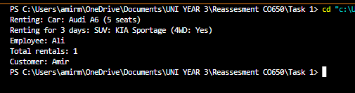

Outputs details of the client and what employee has rented the car to the client, in addition to the car model etc...

## Abstraction

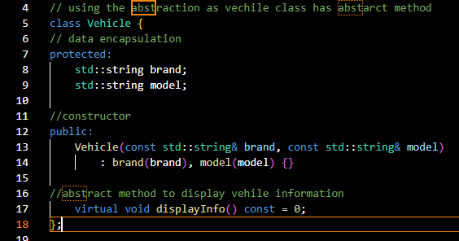

Abstraction is used to hide the internal implementation details, here its used to display the Car details and the customers details.

## Encapsulation

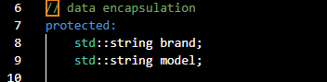

Encapsulation is used to bundle data into a location and store it for recall later, this system used it to contain the car information details and store them to access when called on.

## Inheritance

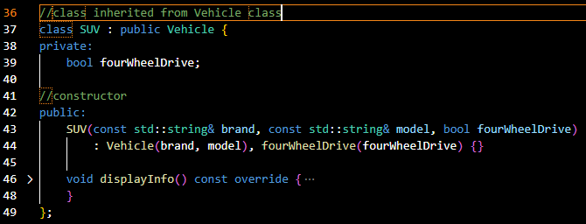

Inheritance is used to avoid making large repetitions of the code and allows the user to set data and be able to inherit its attributes when called. In this case its been used twice to inherit the vehicles class attributes.

## Polymorphic Behaviour

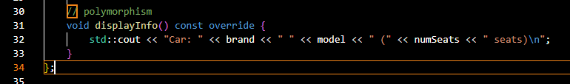

## Overloading

Overloading allows a method with the same name to be declared multiple times and display a different output once they have been given a different input parameter, in this case it aids in displaying the different output parameters for rented cars and how long for.

## Friendship

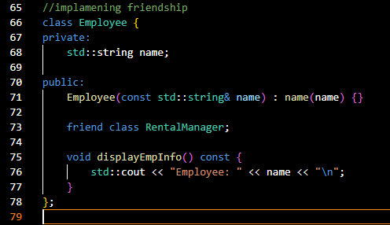

Friendship is used to provide access to private and public classes as a “friend”. Here it grants access to the private class of the employee’s name.

## Static Members

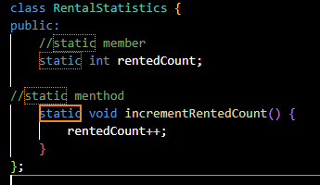

A Static member means no matter how many objects of the class are created, there is only one copy of the static member, this case uses the static members for the rentedCount which displays the number of rented cars for the client.

## Constructors

The purpose of the constructors is to construct an object and assign values to the object’s members. In these cases, it constructs the output message and assembles the car details.

## Pointers

A pointer contains a variable of an address to another variable, here it helps with the car details.

## Functional Pointers

## Task 1 Conclusion: -

To summarize this task was a unique experience that allowed me to create a semi functioning car rental system. I was able to create an example of each point in the assignment brief and it allowed me to display specific details that could be used for a rental car system.

## Extra Code Explanation :

The `Vehicle` class serves as an abstract base class with a protected data section for brand and model information. It has a constructor to initialize these attributes, and it declares a pure virtual function `displayInfo()` that must be overridden by derived classes.

The `Car` class inherits from the `Vehicle` class, adding an attribute `numSeats` to represent the number of seats in the car. It overrides the `displayInfo()` method to display car information, including the number of seats.

The `SUV` class similarly inherits from `Vehicle`, but it includes an attribute `fourWheelDrive` to indicate if the SUV has four-wheel drive. It also overrides the `displayInfo()` method to display SUV information.

The `RentalManager` class demonstrates function overloading. It has two `rent` methods: one that takes a `Vehicle` parameter and one that takes both a `Vehicle` parameter and an integer representing the rental days. These methods print information about the rental.

The `Employee` class has a private attribute `name`. It is a friend of the `RentalManager` class, allowing `RentalManager` to access its private members. It includes a method `displayEmpInfo()` to display employee information.

The `RentalStatistics` class showcases the use of static members. It has a static variable `rentedCount` to keep track of the number of rentals. The static method `incrementRentedCount()` increments this count.

The `Customer` class represents a customer with a private attribute `name`. It has a method `displayCusInfo()` to display customer information.

# Task 2: -

## Classes Link: -

Server.cpp

<https://github.com/Amir94Mohamed/CO650A.D.-Referal/blob/main/Task%202%20(SERVER)/Server.cpp>

Client.cpp

<https://github.com/Amir94Mohamed/CO650A.D.-Referal/blob/main/Task%202%20(SERVER)/Client.cpp>

Comms.h

<https://github.com/Amir94Mohamed/CO650A.D.-Referal/blob/main/Task%202%20(SERVER)/Comms.h>

Common.h

<https://github.com/Amir94Mohamed/CO650A.D.-Referal/blob/main/Task%202%20(SERVER)/Common.h>

## Code ScreenShots

### Server.cpp

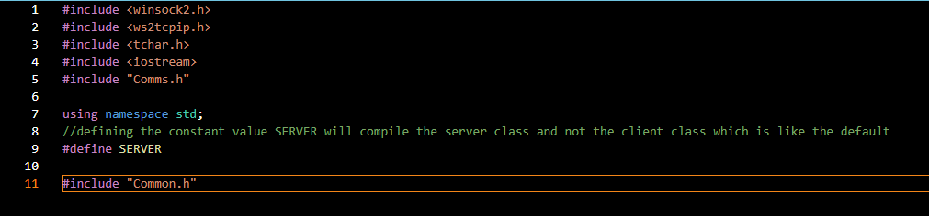

This is used to open a server that a client can connect too, it uses the Comms.h & Common.h files to do the connections.

### Client.cpp

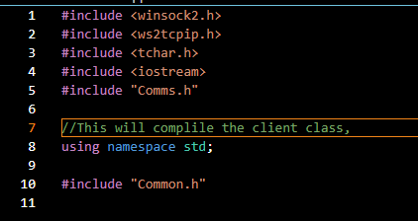

This code is what ensures the client code is running which is the default. This is used to open a client chat that can connect to the server and type, it uses the Comms.h & Common.h files to do the connections.

### Common.h

Common.h aids with the connections established between the client and server, it displays messages to inform the client of the situation. For example it would display “Shut down in progress” if the user typed QUIT to close the program.

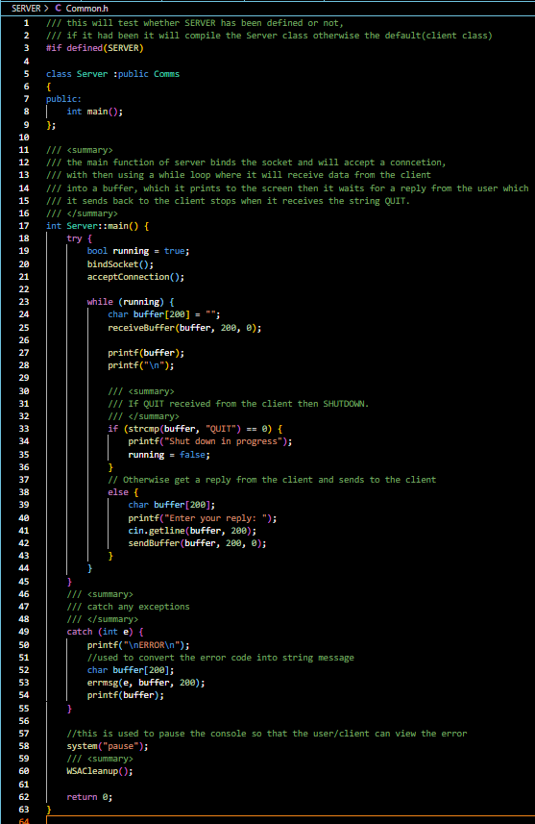

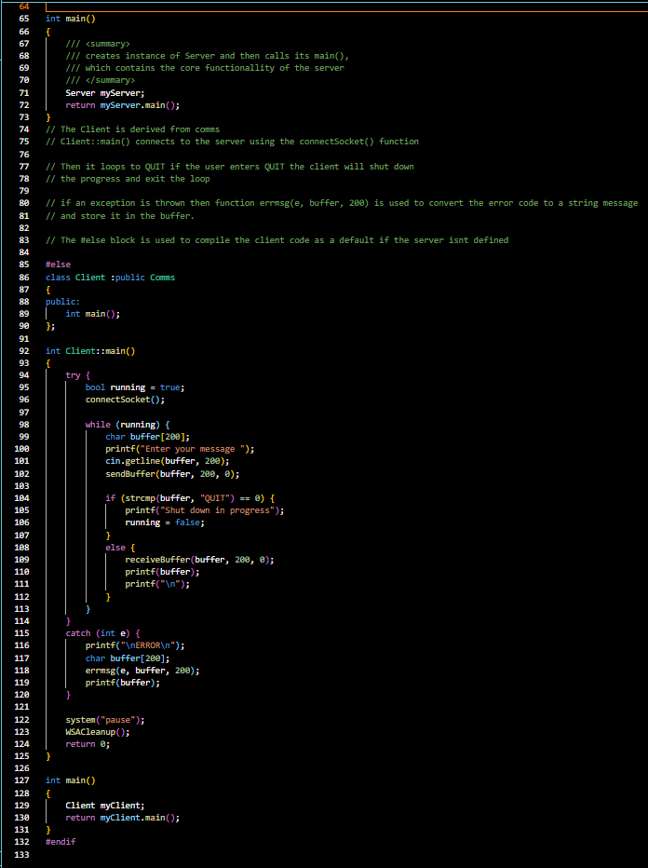

### Comms.h

The comms.h file oversaw the communications between the client and server. Specifically, the communications that need to be established for the connection to succeed such as creating the sockets, accepting and error message if failed connection.

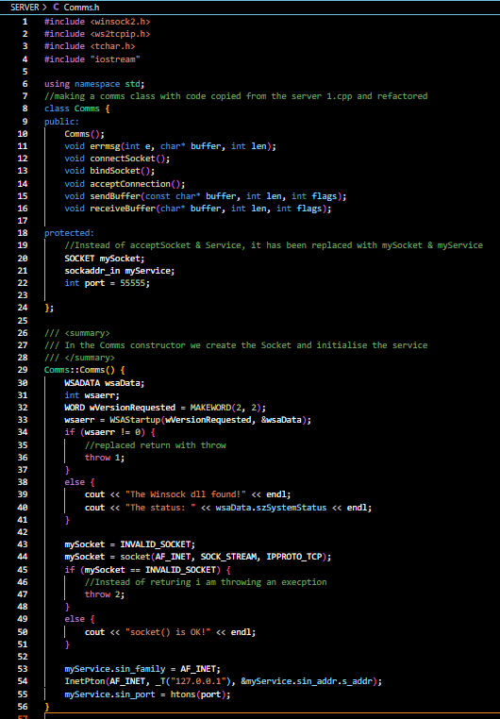

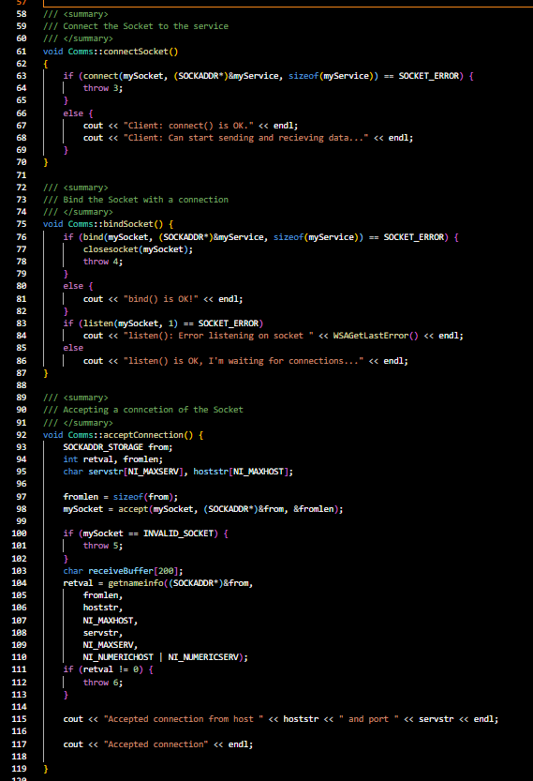

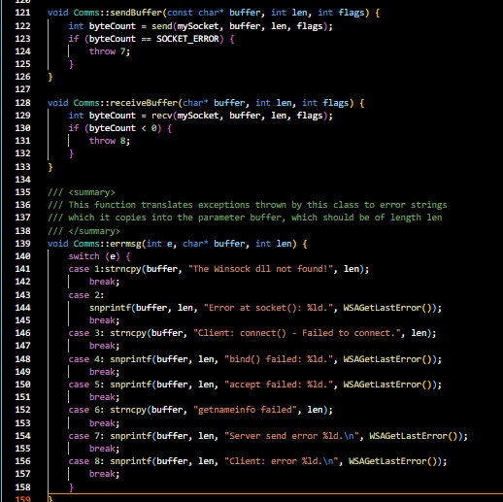

## Console Output

### Successful connection

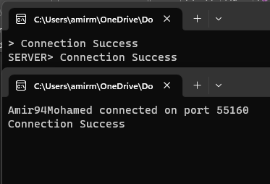

### Quitting Client

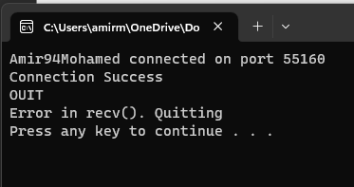

### Quitting server

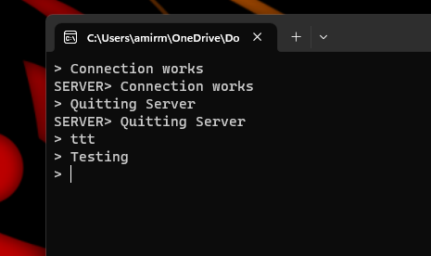

### Client Tries to connect (server OFF)

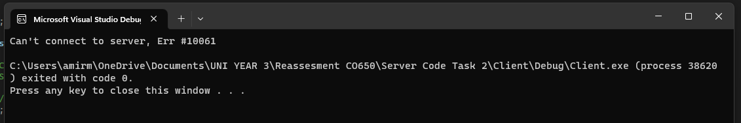

### Server waiting for connection from Client

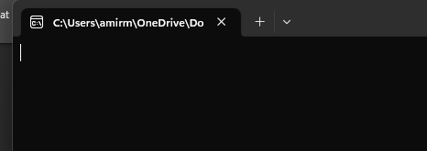

## Task 2 Conclusion: -

To summarize this was a good experience and practice, It was quite unique and required further research into the task to complete it. My main issue was the C++ language and my lack of experience in the language. The result was functional but had some issues that would cause it to display the wrong message but eventually fixed by displaying a different message.

## GitHub Link: -

<https://github.com/Amir94Mohamed/CO650A.D.-Referal/tree/main/Task%202%20(SERVER)>